How to Access the WPQC Homestudy

Training & Resource Documents
Step 1. Visit www.pswi.org and click Sign In

Step 2. Enter your Username and Password and click Sign In
Step 3. Access your User Account by clicking My Account (top right corner of screen)

Step 4. Click Manage My Account

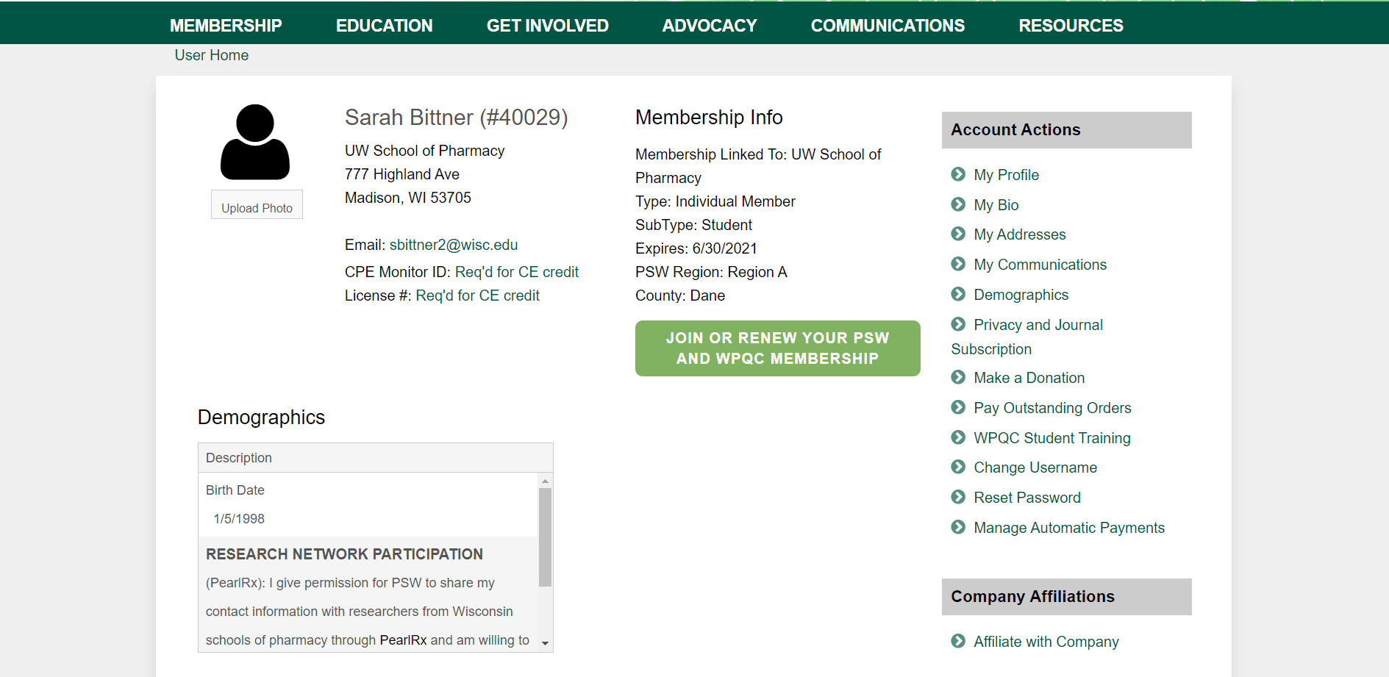
Step 5. Under Account Actions select WPQC Training

Step 6. Select the Title of the Homestudy Training that applies to you
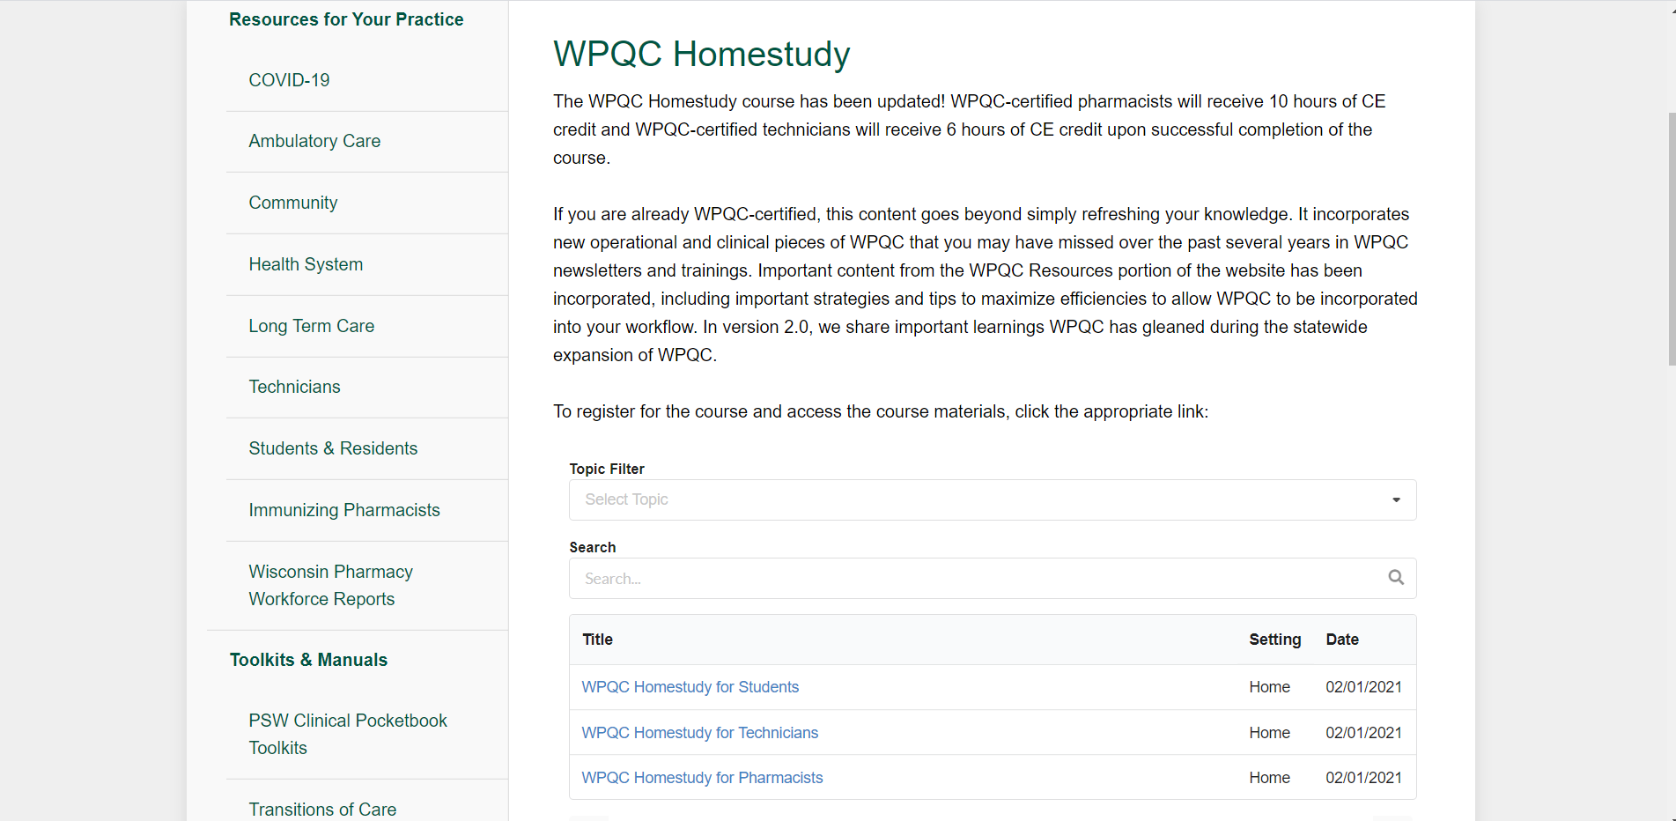

Step 7. You will now be able to begin completing the Homestudy, pick up where you left off with the material, and/or access all of the available WPQC Homestudy Resources
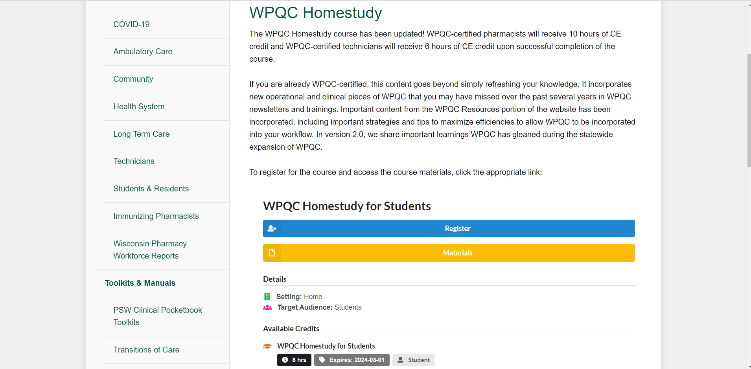

Step 8. To access the Module Slides or the WPQC Resource Manual select Materials

Step 9. Select the Resource you wish to download
